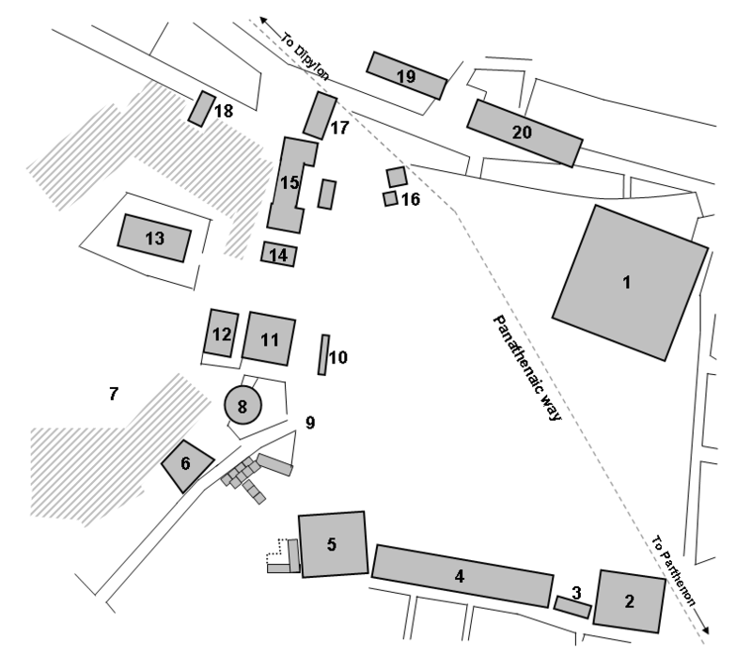

ATHENIAN AGORA
1 Peristyle Court
2 Mint
3 Enneakrounos
4 South Stoa I and South Stoa II
5 Aiakeion
6 Strategeion
7 Agoraios Kolonos
8 Tholos
9 Agora stone
10 Monument of the Eponymous Heroes
11 Metroon (Old Bouleuterion)
12 New Bouleuterion
13 Temple of Hephaestus (Hephaestion)
14 Temple of Apollo Patroos
15 Stoa of Zeus
16 Altar of the Twelve Gods
17 Stoa Basileios (Royal stoa)
18 Temple of Aphrodite Urania
19 Stoa of Hermes
20 Stoa Poikile

